Camp Resources 2017 – Registration Instructions
Screen 1. Fill out form, then click “Add to basket”
a. Invoice Number: Camp Resources 2017
b. Company/Affiliation/Agency: Attendee’s affiliated institution or agency
c. Payer First and Last Name, Email, Phone #: Attendee’s information
d. NC State Contact Name or Department: CEnREP-Jane M. Casteline
e. Please enter payment amount: Faculty: 75; Student: 50 (for form, do NOT include “$”)
Screen 2: Review information, then click, “Checkout”
Screen 3: Click “Continue as Guest” button

Screen 4: Fill out form, then click “Continue Checkout”
(for County, select “N/A”)
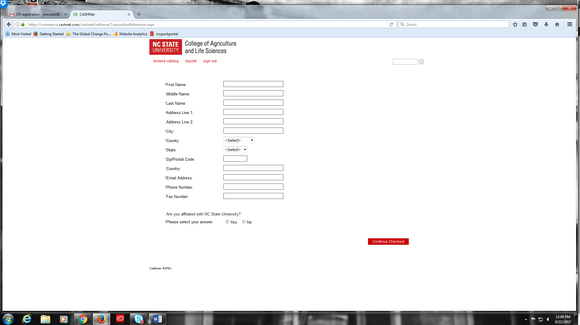

Screen 5: Click “Continue Checkout”
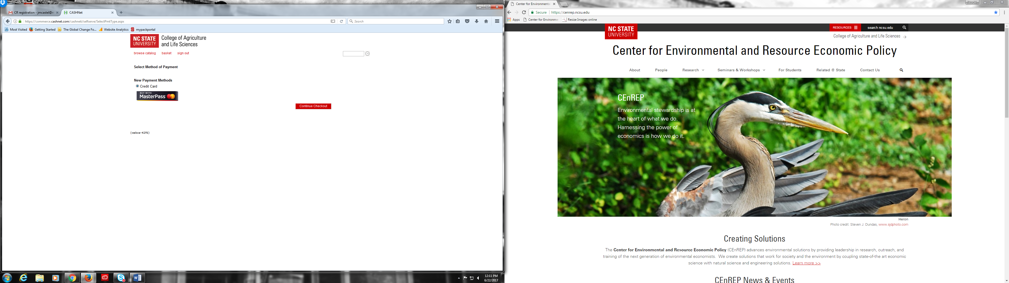

After this screen you will be asked to enter your payment info, then click “Continue Checkout”
Review your information. Then click “Submit Payment”
A receipt will be sent by “ncsuecommerce@ncsu.edu” to the email address you provided.

